CS 584: Machine Learning

Pradyot Mayank

A20405826

Assignment 1

# Question 1 (40 points)

Write a Python program to calculate the density estimator of a histogram. Use the field *x* in the NormalSample.csv file.

1. (5 points) According to Izenman (1991) method, what is the recommended bin-width for the histogram of x?

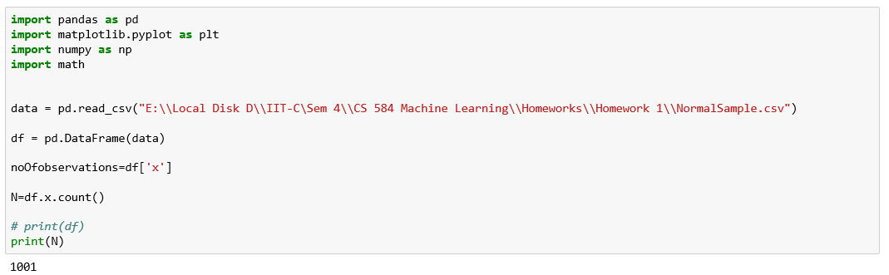

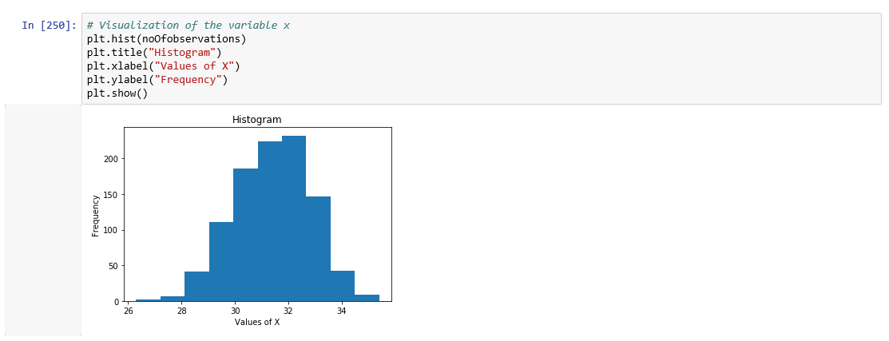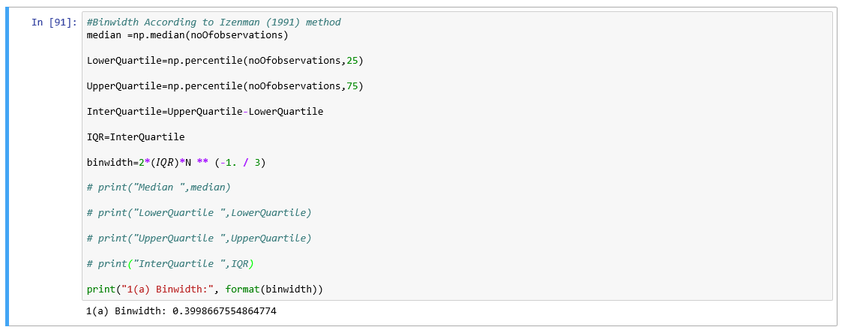

**So, binwidth according to Izenman (1991) method is 0.3998667554864774.**

1. (5 points) What are the minimum and the maximum values of the field x?

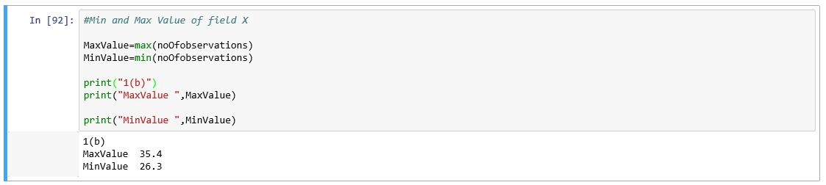

**Minimum Value of x= 26.3**

**Maximum Value of x=35.4**

1. (5 points) Let a be the largest integer less than the minimum value of the field x, and b be the smallest integer greater than the maximum value of the field x. What are the values of a and b?

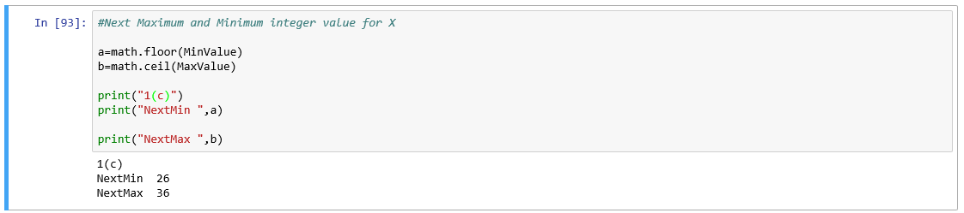

**Value of a=26.**

**Value of b=36.**

1. (5 points) Use h = 0.1, minimum = a and maximum = b. List the coordinates of the density estimator. Paste the histogram drawn using Python or your favorite graphing tools.

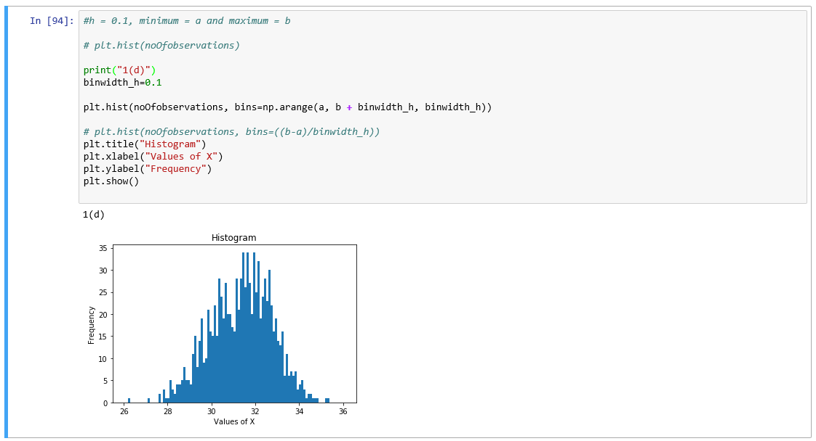

1. (5 points) Use h = 0.5, minimum = a and maximum = b. List the coordinates of the density estimator. Paste the histogram drawn using Python or your favorite graphing tools.

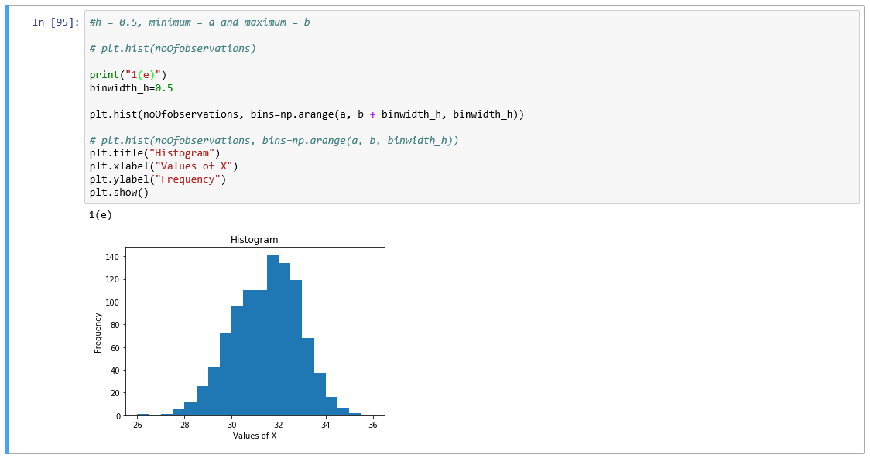

1. (5 points) Use h = 1, minimum = a and maximum = b. List the coordinates of the density estimator. Paste the histogram drawn using Python or your favorite graphing tools.

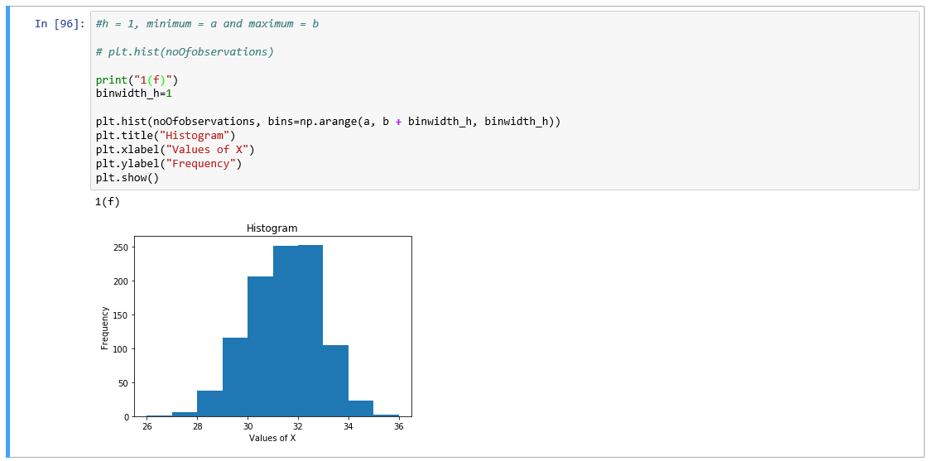

1. (5 points) Use h = 2, minimum = a and maximum = a. List the coordinates of the density estimator. Paste the histogram drawn using Python or your favorite graphing tools.

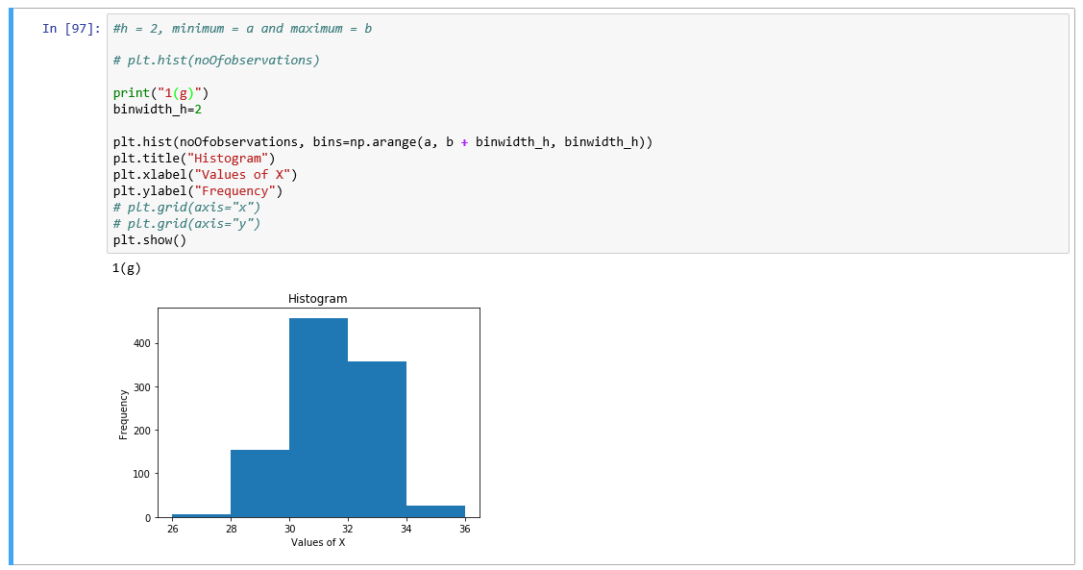

1. (5 points) Among the four histograms, which one, in your honest opinions, can best provide your insights into the shape and the spread of the distribution of the field x? Please state your arguments.

The histogram in part (e) with binwidth=0.5 can best provide the insights into the shape and the spread of the distribution of the field x. As the binwidth calculated in part (a) is 0.4 (upto 1 decimal place). The nearest next binwidth is 0.5 in part (e) and also it provides almost symmetric distribution of data, not skewed left or right.

# Question 2 (20 points)

Use in the NormalSample.csv to generate box-plots for answering the following questions.

1. (5 points) What are the five-number summary of x? What are the values of the 1.5 IQR whiskers?

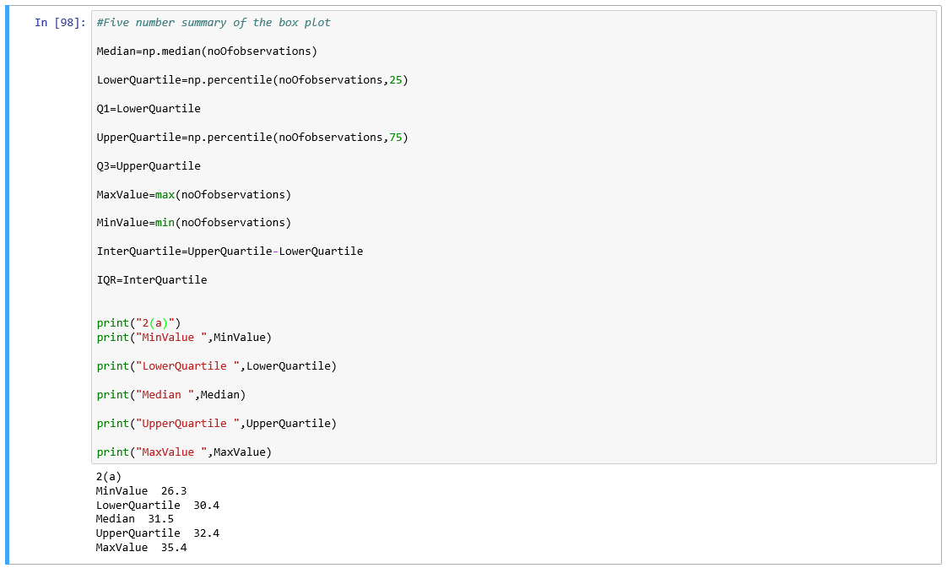

**Five number summary of x:**

Minimum Value=26.3

Lower Quartile Q1=30.4

Median =31.5

Upper Quartile Q3=32.4

Maximum Value= 35.4

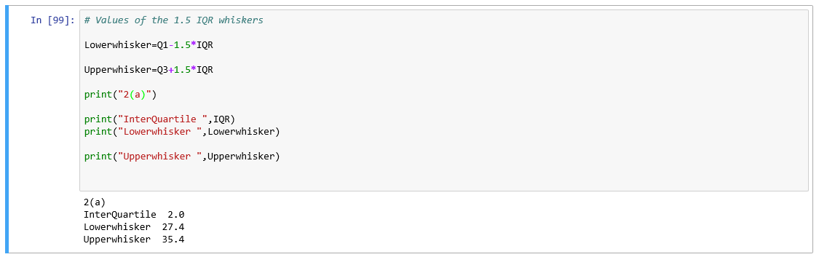

**Value of whiskers:**

Lower Whisker= 27.4

Upper Whisker= 35.4

1. (5 points) What are the five-number summary of x for each category of the group? What are the values of the 1.5 IQR whiskers for each category of the group?

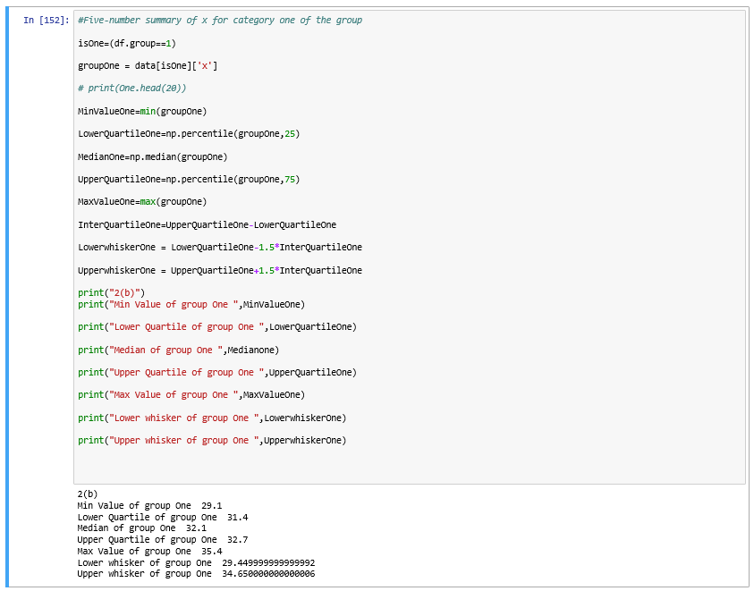

**Five number summary for category One:**

Minimum value =29.1

Lower Quartile=31.4

Median =32.1

Upper Quartile= 32.7

Maximum value=35.4

**1.5IQR wishkers:**

Lower whisker= 29.449999999999992

Upper Whisker= 34.650000000000006

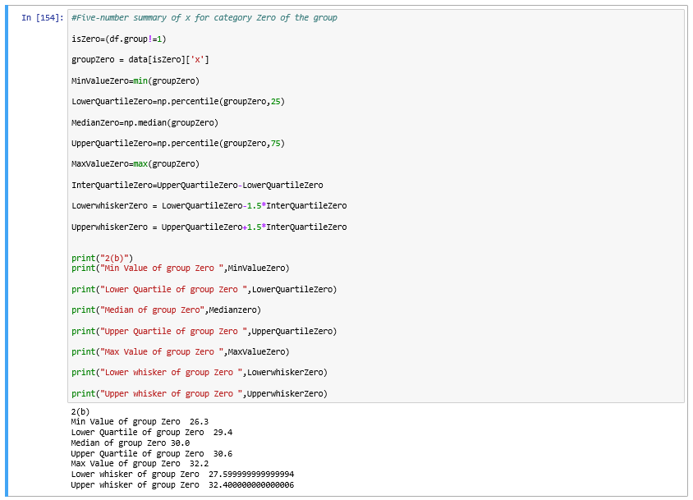

**Five number summary for category Zero:**

Minimum value =26.3

Lower Quartile=29.4

Median =30.0

Upper Quartile= 30.6

Maximum value=32.2

**1.5IQR wishkers:**

Lower whisker= 27.599999999999994

Upper Whisker= 32.400000000000006

1. (5 points) Draw a boxplot of x (without the group) using the Python boxplot function. Can you tell if the Python’s boxplot has displayed the 1.5 IQR whiskers correctly?

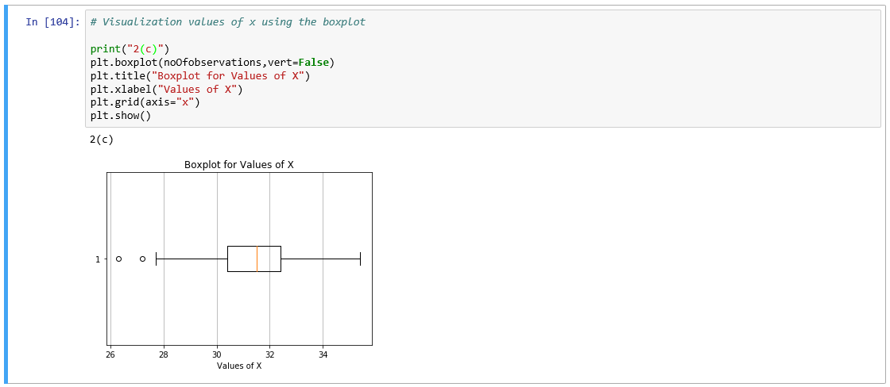

Yes, the above boxplot of value of x has displayed the 1.5IQR whiskers correctly

1. (5 points) Draw a graph where it contains the boxplot of x, the boxplot of x for each category of Group (i.e., three boxplots within the same graph frame). Use the 1.5 IQR whiskers, identify the outliers of x, if any, for the entire data and for each category of Group.  
   *Hint: Consider using the CONCAT function in the PANDA module to append observations*.

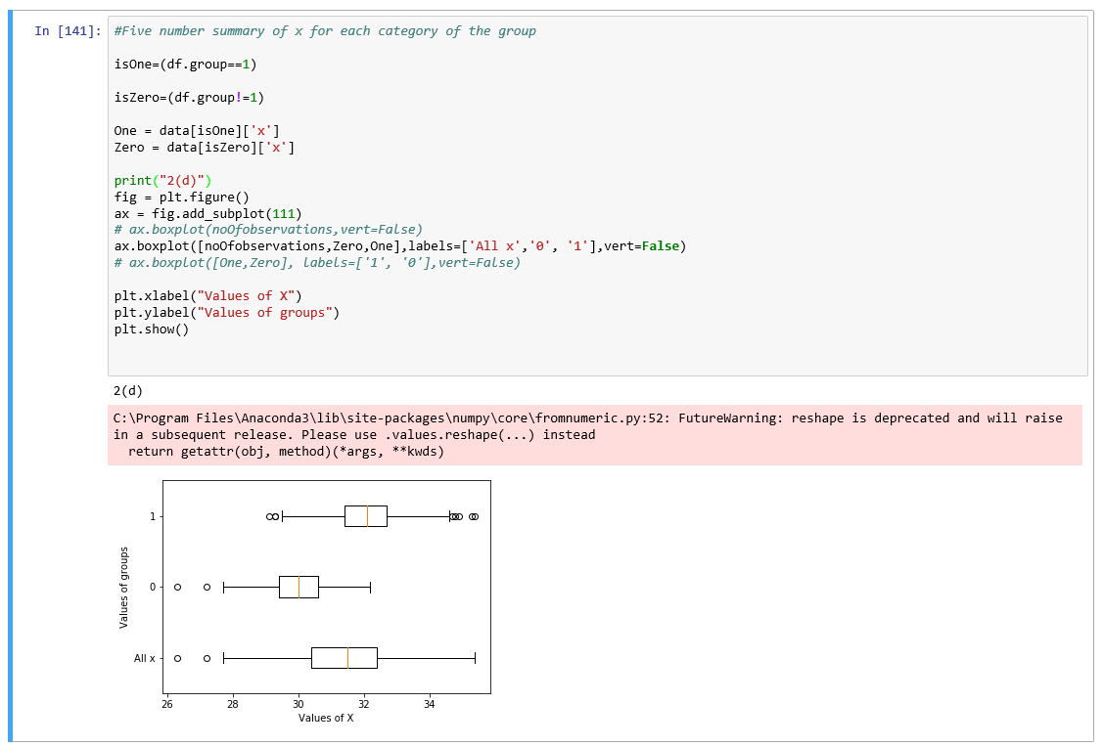

**Outliers of x for all data:**

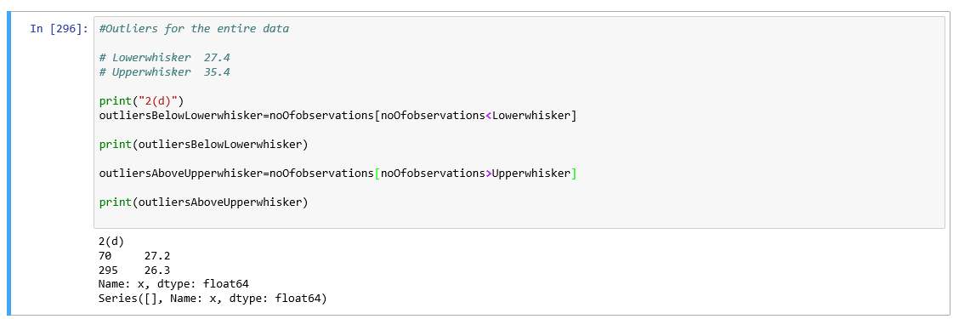

**Outliers for group one:**

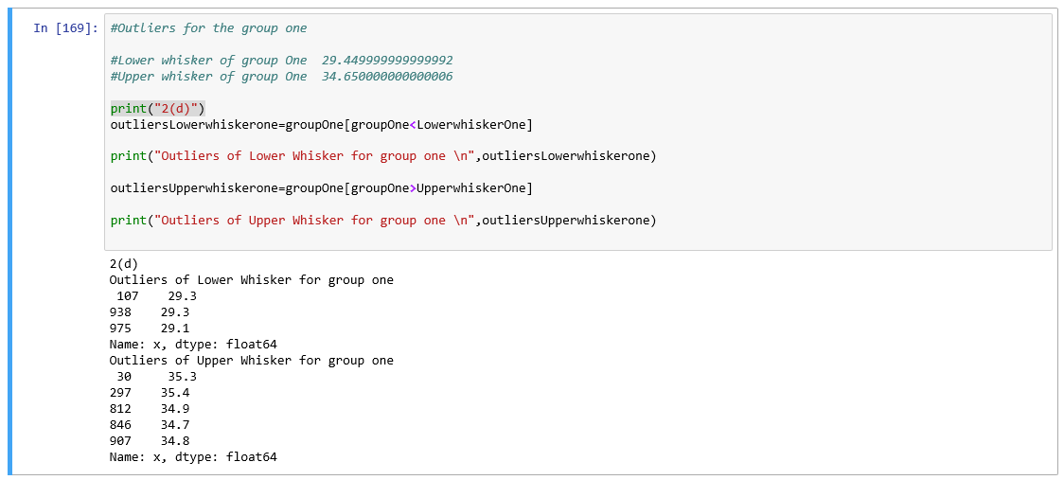

**Outliers for group zero:**

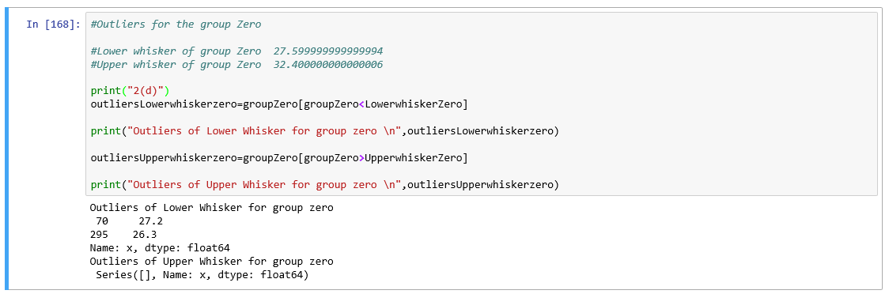

# Question 3 (40 points)

The data, FRAUD.csv, contains results of fraud investigations of 5,960 cases. The binary variable FRAUD indicates the result of a fraud investigation: 1 = Fraudulent, 0 = Otherwise. The other interval variables contain information about the cases.

1. TOTAL_SPEND: Total amount of claims in dollars
2. DOCTOR_VISITS: Number of visits to a doctor
3. NUM_CLAIMS: Number of claims made recently
4. MEMBER_DURATION: Membership duration in number of months
5. OPTOM_PRESC: Number of optical examinations
6. NUM_MEMBERS: Number of members covered

You are asked to use the Nearest Neighbors algorithm to predict the likelihood of fraud.

1. (5 points) What percent of investigations are found to be fraudulent? Please give your answer up to 4 decimal places.

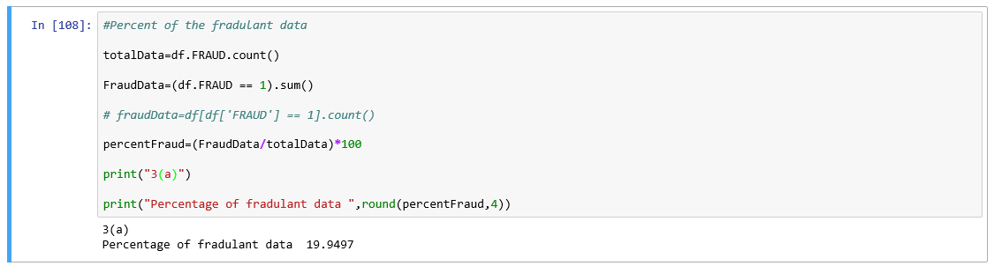

Percent of Fraudulent data =19.9497

1. (5 points) Use the BOXPLOT function to produce horizontal box-plots. For each interval variable, one box-plot for the fraudulent observations, and another box-plot for the non-fraudulent observations. These two box-plots must appear in the same graph for each interval variable.
2. **Total Money Spend**

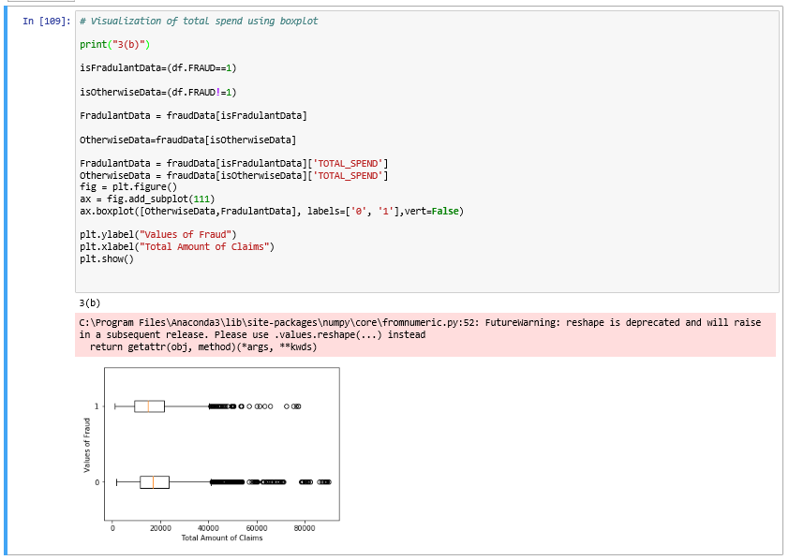

1. **Doctor Visits**

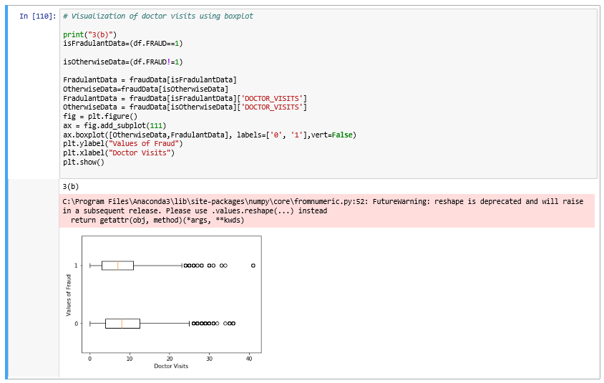

1. **Number of Claims**

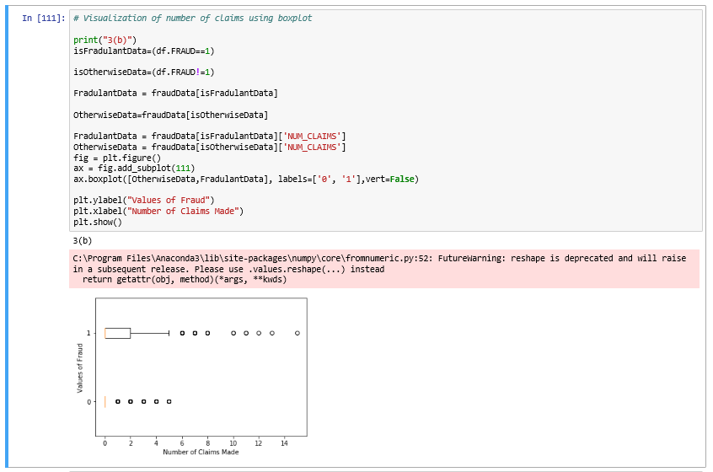

1. **Membership Duration**

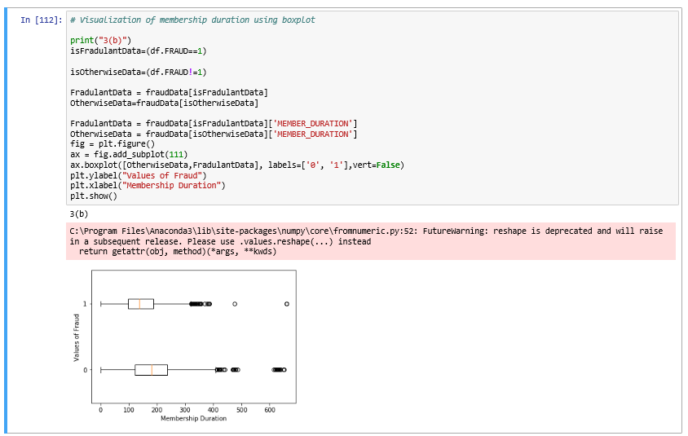

1. **Optical examination**

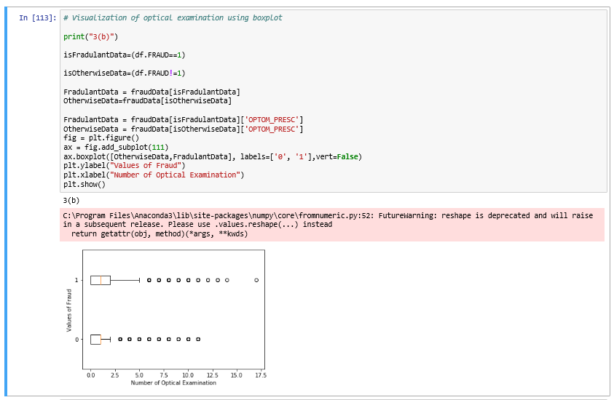

1. **Number of Members**

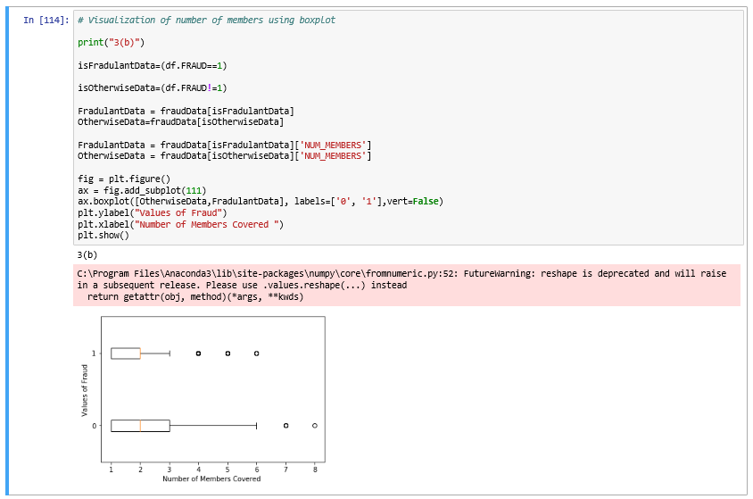

1. (10 points) Orthonormalize interval variables and use the resulting variables for the nearest neighbor analysis. Use only the dimensions whose corresponding eigenvalues are greater than one.
   1. (5 points) How many dimensions are used?

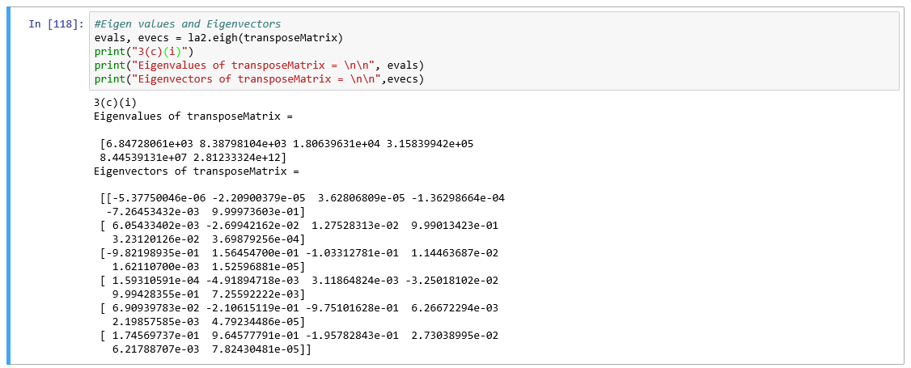

As we can see from the above screenshot, six dimensions are used.

All the eigenvalues are greater than one.

* 1. (5 points) Please provide the transformation matrix? You must provide proof that the resulting variables are actually orthonormal.

**Transformation Matrix:**

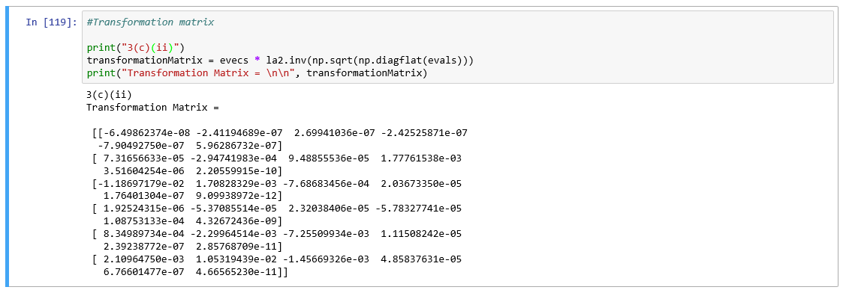

**Proof that the resulting variables are orthonormal:**

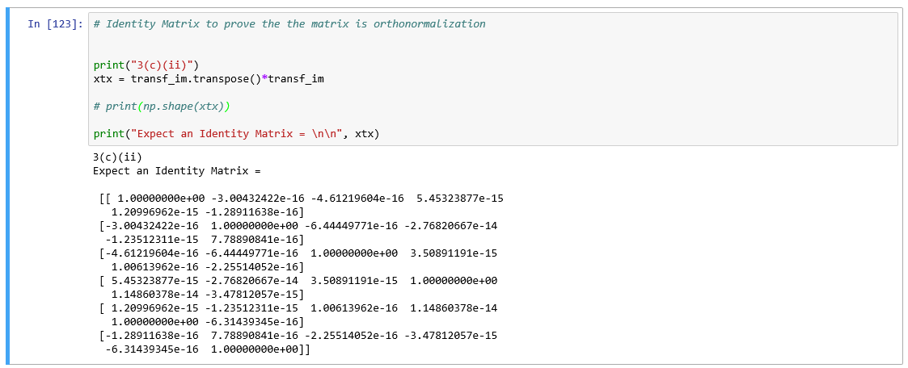

1. (10 points) Use the NearestNeighbors module to execute the Nearest Neighbors algorithm using exactly five neighbors and the resulting variables you have chosen in c). The KNeighborsClassifier module has a score function.
   1. (5 points) Run the score function, provide the function return value.

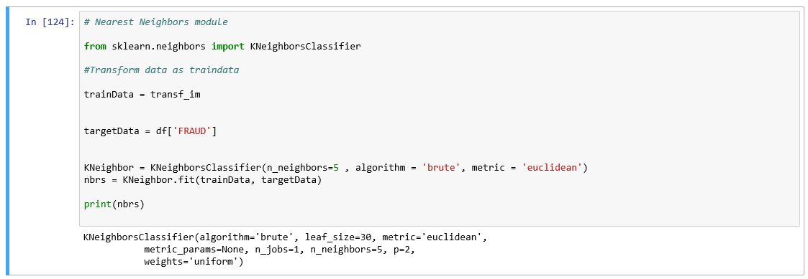

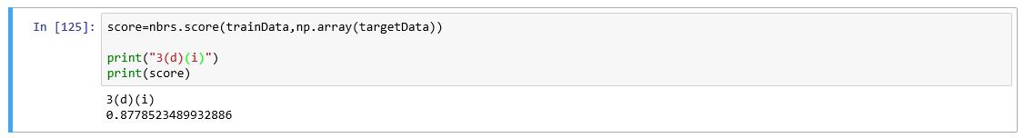

The score function return value is **0.8779** up to four decimal places.

* 1. (5 points) Explain the meaning of the score function return value.

Score function tells us the accuracy of our model which we have trained on our training data.

1. (5 points) For the observation which has these input variable values: TOTAL_SPEND = 7500, DOCTOR_VISITS = 15, NUM_CLAIMS = 3, MEMBER_DURATION = 127, OPTOM_PRESC = 2, and NUM_MEMBERS = 2, find its **five** neighbors. Please list their input variable values and the target values. *Reminder: transform the input observation using the results in c) before finding the neighbors*.

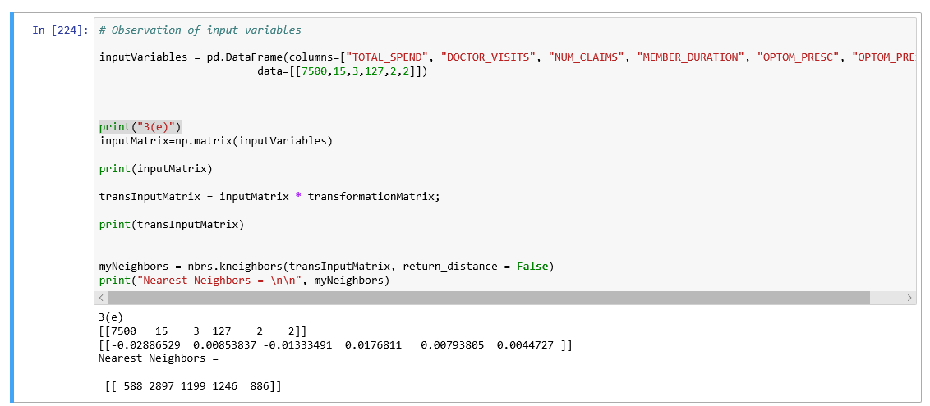

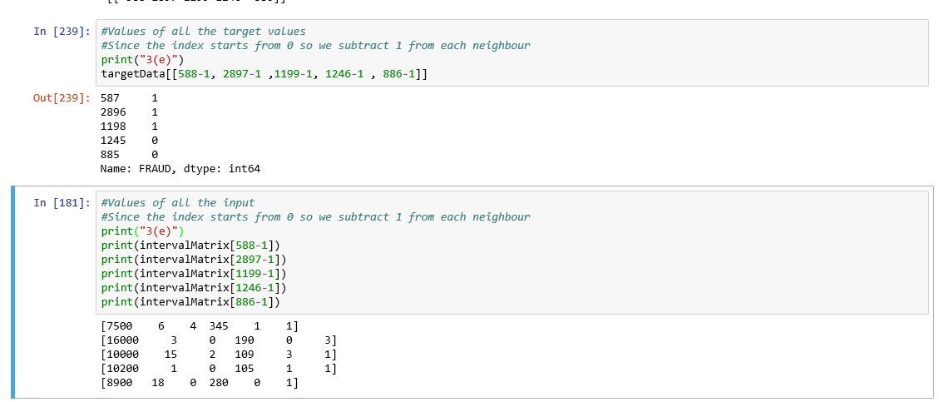

1. (5 points) Follow-up with e), what is the predicted probability of fraudulent (i.e., FRAUD = 1)? If your predicted probability is greater than or equal to your answer in a), then the observation will be classified as fraudulent. Otherwise, non-fraudulent. Based on this criterion, will this observation be misclassified?

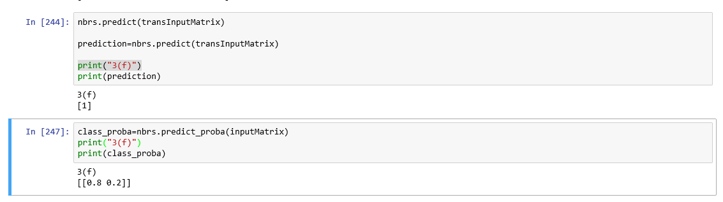

The predicted probability of fraudulent is 20% or 0.2.

No, this observation is not misclassified.